chapter12 Programming with ggplot2

library(ggplot2)  
library(gridExtra)

## 12.1 Introduction

code duplication!

## 12.2 Single Components

More flexibility!! by using function!!

- “…” : allows a function to accept arbitrary additional arguments.

geom_lm = function(formula = y~x, colour = alpha("steelblue", 0.5),  
 size = 2, ...){  
 geom_smooth(formula = formula, se = FALSE, method = "lm", colour = colour, size = size)  
}  
  
g1 = ggplot(mpg, aes(displ, 1/hwy)) +  
 geom_point() +  
 geom_lm()  
  
g2 = ggplot(mpg, aes(displ, 1/hwy)) +  
 geom_point() +  
 geom_lm(y~poly(x,2), size = 1, colour = "red")  
  
grid.arrange(g1,g2, ncol = 2)

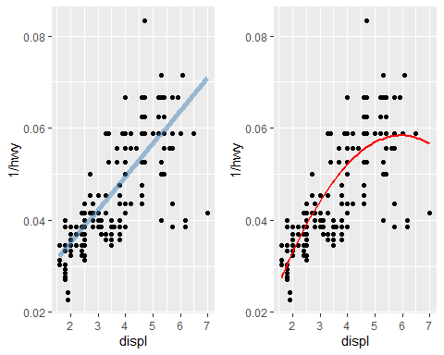

## 12.3 Multiple Components

Adding multiple components to a plot in on step with a **list**!

geom_mean = function(se = TRUE){  
 list(  
 stat_summary(fun.y = "mean", geom = "bar", fill = "grey70"),  
 if (se)  
 stat_summary(fun.data = "mean_cl_normal", geom = "errorbar", width = 0.4)  
 )  
}  
  
g1 = ggplot(mpg, aes(drv, cty)) + geom_mean()  
g2 = ggplot(mpg, aes(drv, cty)) + geom_mean(se = FALSE)  
  
grid.arrange(g1,g2, ncol = 2)

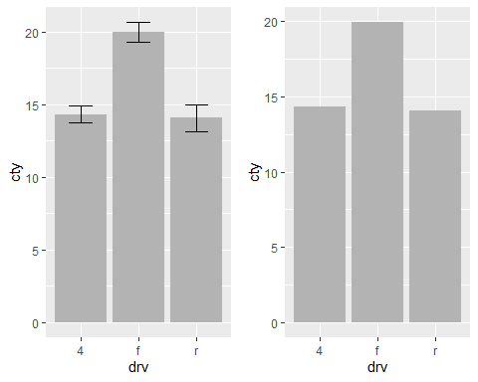

### 12.3.1 Plot Components

Not only adding layers : you can include - data.frame - aes() object - Scales - Coordinate systems, facetting specification - Theme components

## 12.5 Functional Programming

geoms <- list(  
 geom_point(),  
 geom_boxplot(aes(group = cut_width(displ, 1))),  
 list(geom_point(), geom_smooth())  
)  
  
p <- ggplot(mpg, aes(displ, hwy))  
lapply(geoms, function(g) p + g)

## [[1]]

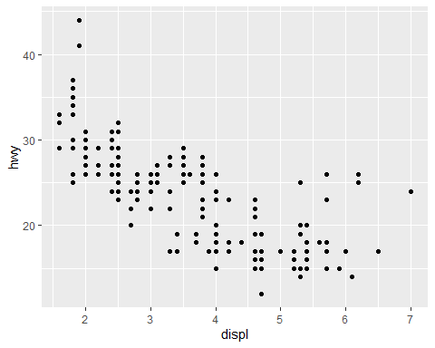

##   
## [[2]]

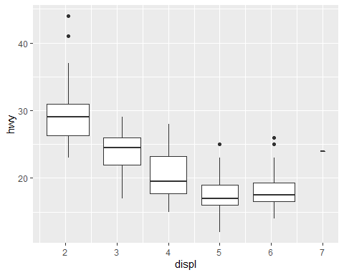

##   
## [[3]]

## `geom_smooth()` using method = 'loess' and formula 'y ~ x'

